# Technical Steering Committee/Work Group Co-Chairs Call

Call in Number: (800) 768-2983

Access Code: 4918837035

## Call Agenda -- August 1st, 2018 9-11 am PDT

* Welcome, Roll Call, and Agenda Review (5 minutes) -- Julie
  + Review notes from June 26th call
  + Notes for this call – Gordon Pierce and Jason Walker
* Work Group Status Reports (informational only, hold discussion) – (30 minutes) – **Work Group Co-Chairs – 5 minutes each TDWG, FSWG, OGWG, & RTOWG – 10 minutes RHPWG –** (see Status Report Guidance and slide template)
* TSC Administrative and Informational Items (25 minutes) – Julie, Frank, Tom, and Pat
  + **Discuss Coordination Needs Identified Above** (5 minutes) - Frank
  + **Action Items** (10 minutes)
    - Review template to identify state staff involvement/commitment for WG Co-chairs – Frank
    - Approve by consensus revised Communication/Coordination Guidance – Frank
  + **Informational Items** (10 minutes)
    - Update on Workplan Deliverables Guidance -- Julie
    - Update on Technical Support System v2 -- Tom
    - Update on Western Regional Haze Planning Assessment project contractor SoW -- Pat
    - Modeling contract update – Tom
    - Data Analysis contract update – Tom
    - TSC/Work Group/Subcommittee member lists posted - Tom
    - [December 4-6, 2018 Salt Lake City in-person WRAP Technical Planning meeting TicketLeap registration link](https://western-regional-air-partnership.ticketleap.com/wrap-2018-technical-planning-meeting/) - Frank
* Review next steps and action items from call (5 minutes) -- Frank
* Next call – August 29th, Wednesday 11:30 am – 1:00 pm Pacific -- Julie
  + Note taker, Joe Tona
  + Agenda items
* **Discussion Topic: Reviewing and revising visibility tracking metric for observational and model output data – goals and hurdles, developing input to contractor plan** (1 hour) – Frank, Tom, Ryan, Tina, and Pat
  + Goals of discussion -- Frank
  + Overview of Visibility and the RHR -- Frank
  + E3 threshold – Ryan Templeton
    - Summary of work by RHPWG Monitoring Data and Glideslope Analysis Subcommittee on Extreme exceptional events (e3) threshold
      * Results and next steps
  + Overview of existing NCII Natural Conditions estimates and ideas/methods to derive new natural conditions estimates – Pat
    - NC estimation methodology
    - Updating estimate
      * Revisit monitor data
      * Modeling
      * Other methods
  + Where on the glide slope or at the 2064 end point to adjust for international and prescribed fire contributions -- Tom
    - FSWG efforts to document Rx/Ag Smoke Mgmt. Programs – present/future
    - FSWG efforts to project ranges of future year (~2028) fire activity and emissions
    - EPRI International Haze study
    - Sensitivity studies by WRAP and other modeling efforts
    - Marrying the modeled RPG with the glideslope
      * Reconciling anthropogenic/natural splits
  + Future technical support– Tom
  + Moving Forward -- Frank

**Call and Note Taking Schedule**



**WRAP Workplan Timeline to Support Regional Haze Progress Reporting**

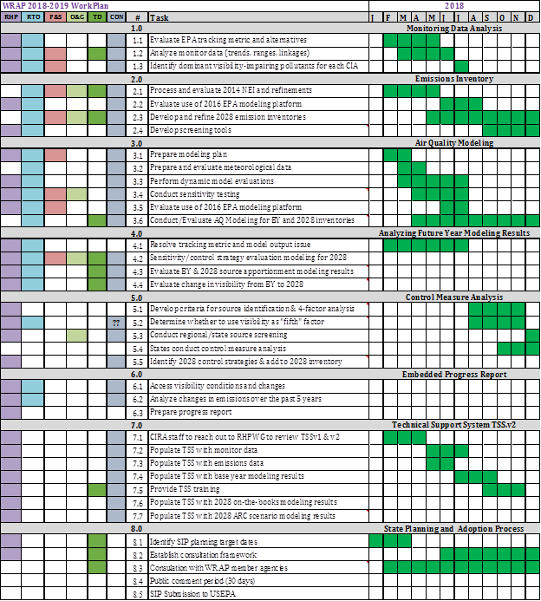

**WRAP Workplan Timeline to Support Regional Technical Analysis**

